Circle objects on the print below and then identify who that idea is associated with.
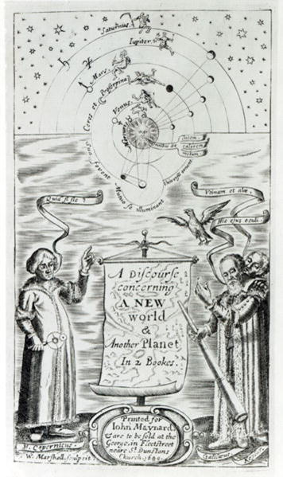
Reflection question: Why were scientists hesitant to come forward with their discoveries?

Extension Question: Name 2 other scientific revolutionaries and their contributions.

