Biomanufacturing
Agricultural Cyberbiosecurity Education Resource Collection
Authored by David Smilnak, Dr. Anne Brown, Dr. Laura Strawn, Jaylan Day, and Dr. Hannah H. Scherer

What is Biomanufacturing?
Biomanufacturing is where science, nature, and business collide. Are you curious about how algae can make rocket fuel? Are you interested in how farming could help fight climate change? These and many more careers come together in biomanufacturing. There is an effort by industries to explore naturally occurring processes to produce the products we all use. Everything from medicine to plastics and, yes, rocket fuel, could have a naturally occurring process to help us make it.
For example, penicillin was one of the most important discoveries in modern medicine. In 1928, Dr. Alexander Fleming discovered penicillin. Using microscopes and Petri dishes, Dr. Fleming recognized that this common and natural mold could destroy harmful bacteria. Penicillin has since drastically lowered the death rate for bacterial infections. This discovery has all the characteristics of a biomanufacturing success: Penicillin is a naturally occurring substance, technology (microscopes and Petri dishes) was used to unlock its potential, and it had an economic impact on the medical industry (as well as others since it increased life expectancy).

A Brief History of Biomanufacturing
The history of biomanufacturing can be broken up into stages: biomanufacturing 1.0, 2.0, 3.0, and 4.0. The stages describe a variety of technological advances and understandings of the natural world.

Biomanufacturing 1.0
Certain biomanufacturing processes, like brewing beer, have been around for as long as civilization itself. Our ancestors may not have understood completely what was happening when they introduced sugar, yeast, and malt to water, but they soon realized that the processes that occurred allowed them to safely “brew” and consume the otherwise dangerous water. Biomanufacturing 1.0 is characterized by a refinement of this “brewing,” or as it is technically called, fermentation.
In the 1910s, Chaim Weizmann, known as the father of industrial fermentation, started to experiment with a process called acetone, butanol, and ethanol (“ABE”) fermentation. In this process, acetone, butanol, and ethanol are metabolites, natural products of a cell’s function like the ethanol our ancestors produced while brewing beer. Weizmann used fermentation to produce acetone and butanol in a large-scale and more commercially viable way. The industrialization of ABE fermentation helped to produce products like synthetic rubber, smokeless gunpowder, paint lacquer for cars, and most recently, biofuels.
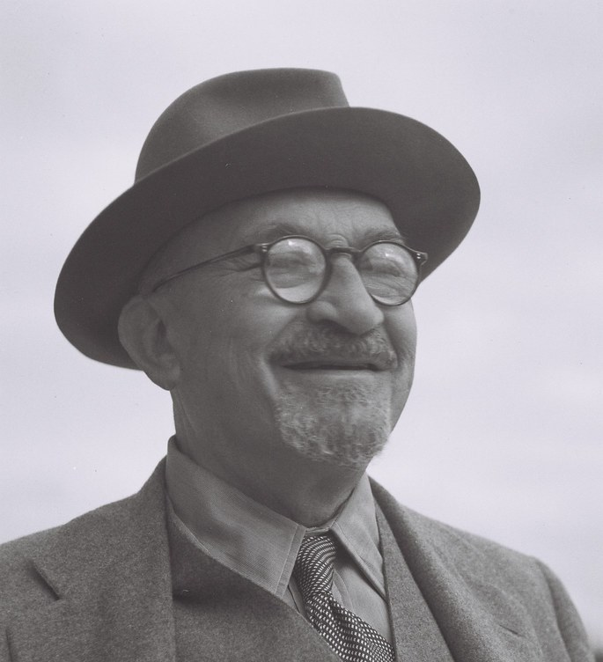
Figure 1. Dr. Chaim Weizmann (1874–1952), Professor of Chemistry at the University of Geneva and then the University of Manchester before becoming the first president of Israel. "President Chaim Weizmann" by the Government Press Office (GPO) is licensed under CC BY-NC-SA 2.0.

Biomanufacturing 2.0
Where biomanufacturing 1.0 utilized the everyday functions of cells to produce products, biomanufacturing 2.0 uses secondary processes. Secondary processes include chemicals that cells can create when they are under attack.
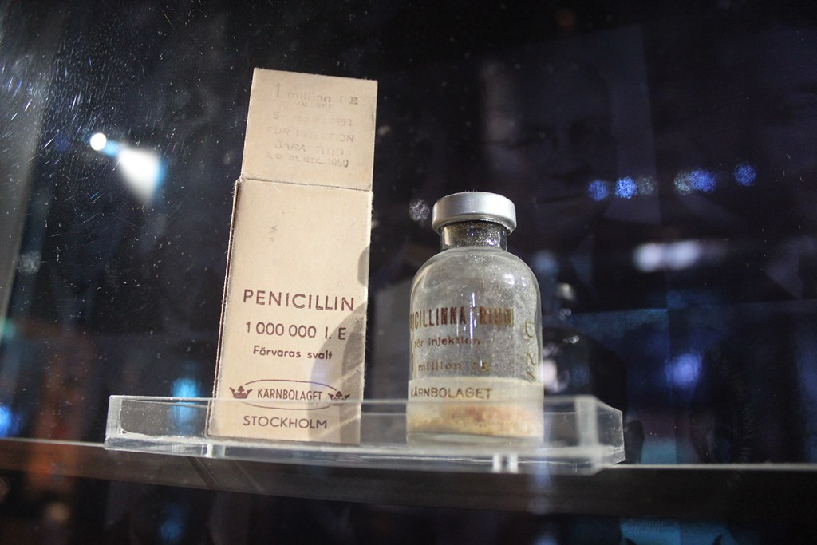
Figure 2. An original bottle of penicillin. "The Discovery of Penicillin" by Solis Invicti is licensed under CC BY 2.0.
The most famous example is the Penicillin story. Because so many of these secondary processes are used by cells for defense, they are ideal for antibiotics. However, they have also been used for flavorings and perfumes. Technological advancements about 20 years after Dr. Fleming’s discovery allowed the production of penicillin, as well as other products, to grow and become cheaper.

Biomanufacturing 3.0
Large biological molecules like insulin and different enzymes were too complex to create using typical chemistry methods. In the 1970s, that started to change. Stanley Cohen and Herbert Boyer pioneered a new method of creating complex molecules like proteins. Their process tricks a bacteria called E. coli into making insulin. This method was so successful that it was used to mass-produce insulin for patients with diabetes.
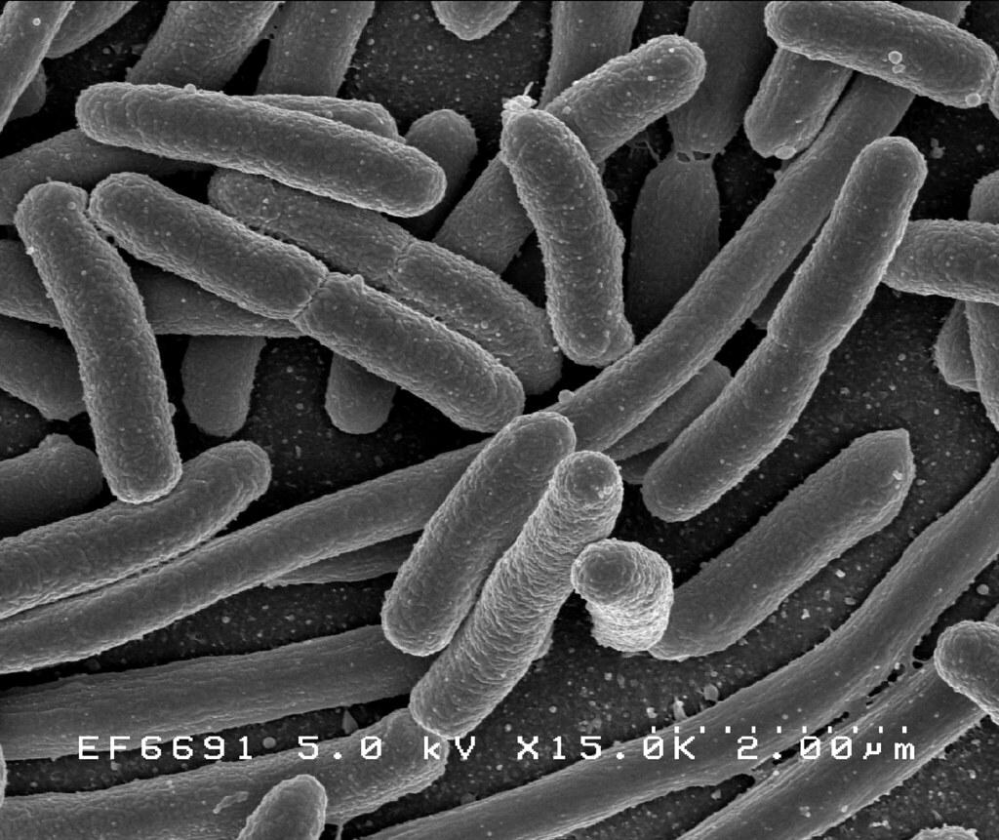
Figure 3. A picture of E. coli taken from an electron microscope. "E. coli Bacteria" by NIAID is licensed under CC BY 2.0.
Recently, this process has allowed for the development of anti-cancer technologies and other enzymes used in the agricultural, clothing, and chemical industries. To continue improving enzyme production, scientists started using plants such as tobacco or the soybean plant rather than E. coli to make these products. Plants are bigger than bacteria, so using these plants means they can make more enzymes and proteins quicker.

Biomanufacturing 4.0
If biomanufacturing 3.0 was about recreating complicated, naturally occurring molecules, biomanufacturing 4.0 will mean creating our own molecules. The future of biomanufacturing is still being shaped by the scientists of today and tomorrow, but it is motivated by finding answers to seemingly impossible questions and by making current processes more efficient. This will likely include the use of Artificial Intelligence (AI) to explore potential combinations and see what works. We haven’t found the limits of biomanufacturing 4.0, and there are some budding areas pushing those limits.

Artificial food
Lab-grown meat, sometimes referred to as cellular agriculture, is a top priority of biomanufacturing 4.0. You may have heard of Impossible Foods and Beyond Meat. These companies are currently in biomanufacturing 3.0, where they mimic meat. In biomanufacturing 4.0, companies are trying to grow it. The ability to grow meat products in a lab has a large variety of societal, environmental, and health benefits namely, the ability to have a source of protein without injuring or killing animals.

Regenerative medicines
Rather than trying to replace human tissues, what if the body could just grow its own? Researchers are exploring the possibility of using stem cells to grow tissue and organs specific to the patient in need. Currently, a patient who receives a transplanted organ will need to take medicine to prevent rejection of the donor organ. If researchers are successful, this will be a thing of the past. In a similar application, biomaterials provide scaffolding on which cells can grow. These materials can then be applied to an injury, allowing tissues and bones to grow back naturally. Research into stem cells and biomaterials is the beginning point of this field, but the future is still being determined.

Connection to Agriculture
Examples of manufactured products in the field of agriculture include genetically modified organisms (GMOs) and agrichemicals. GMO produce and livestock are huge aspects of American agriculture. For example, gene editing has been used to create gray-patched cattle to reduce the amount of heat they absorb. Produce such as corn, apples, cotton, and potatoes are genetically engineered. Most crops have their genes edited to resist pests and diseases. However, some crops, like apples and potatoes, are modified to be more visually appealing to consumers. Some GMO potatoes have been developed to prevent the bruising and browning that occur when potatoes are packaged, stored, and transported. GMO apples were made to prevent browning since browning is often mistaken as a sign of an apple spoiling. Furthermore, many processes that other industries use have a connection to agriculture. Cellular processes in wheat, tobacco, and soy have proven to be useful for scientists exploring DNA technology.
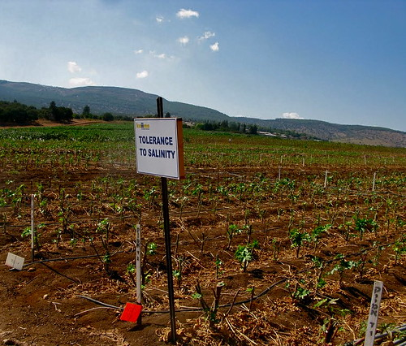
Figure 4. Growing salt-resistant crops. "Polyploidal Plants" by jurvetson is licensed under CC BY 2.0.
Lastly, biomanufacturing has implications for agriculture. While lab-grown meat is beneficial for the environment and animal welfare, the social implications for ranchers and farmers are often ignored. How will lab-grown meat affect the farmers who raise cattle or grow food for those cattle?

Connection to Cyberbiosecurity
Biomanufacturing is one of the fields that cyberbiosecurity is focused on protecting. Biomanufacturing 4.0 coincides with the digitization of industry. As you can imagine, the work that scientists are doing and will do in the future will require a lot of computing power. As such, biomanufacturing businesses are a prime target for cyberattacks.
Agricultural and industrial biomanufacturing attacks are usually limited to a single business. These attacks target the intellectual property those businesses are working on. Also, cyberattacks in biomanufacturing are likely to be cyber-physical instead of data-based. An example would be the disruption of an assembly line compared to stolen data about the monthly production report of a business.

Glossary
Acetone: A chemical solvent often found in nail polish remover.
Butanol: A chemical solvent often used with paint, lacquer, and other coatings.
Ethanol: Chemical responsible for drinking alcohol. It is also used as an antiseptic, medicinal solvent, and fuel for transportation.
Antibiotic: A medicine that kills or prevents the growth of pathogens.
Mutant strains: A naturally occurring variation of a cell, pathogen, or virus.
Gene: A collection of DNA found in chromosomes that controls what characteristics are passed on to a person, animal, or plant.
Enzyme: A molecule that speeds up a chemical reaction.
Stem Cells: Cells in people, plants, and animals that go on to become specialized cells in the organism like skin cells, liver cells, reproductive cells, blood cells, etc. They are the first stage of cell production.
Biotechnology: The application of biology to an industrial process.
Cyber-physical Attack: A cyberattack that results in the physical interruption of a non-cyber process.

References
Collins, M. N., Ren, G., Young, K., Pina, S., Reis, R. L., & Oliveira, J. M. (2021). Scaffold Fabrication Technologies and Structure/Function Properties in Bone Tissue Engineering. Advanced Functional Materials, 31(21), 2010609. https://doi.org/10.1002/adfm.202010609
Iattici, F., Catallo, M., & Solieri, L. (2020). Designing New Yeasts for Craft Brewing: When Natural Biodiversity Meets Biotechnology. Beverages, 6(1), 3. https://doi.org/10.3390/beverages6010003
Northeast Biomanufacturing Center & Collaborative (2016). Chapter 1: Introduction. Introduction to Biomanufacturing. Montgomery County Community College.
Sergelidis, D. (2019). Lab Grown Meat: The Future Sustainable Alternative to Meat or a Novel Functional Food. Biomedical Journal of Scientific & Technical Research, 17(1), 12440-12444. https://doi.org/10.26717/BJSTR.2019.17.002930
Shi, S., Wang, Z., Shen, L., & Xiao, H. (2022). Synthetic biology: A new frontier in food production. Trends in Biotechnology, 40(7), 781–803. https://doi.org/10.1016/j.tibtech.2022.01.002
Zhang, Y. H. P., Sun, J., & Ma, Y. (2017). Biomanufacturing: History and perspective. Journal of Industrial Microbiology and Biotechnology, 44(4–5), 773–784. https://doi.org/10.1007/s10295-016-1863-2

Additional Resources
Bryans, M. (n.d.). What is Biomanufacturing? http://biomanufacturing.org/teacherresources/high-school-teacher-resources/what-is-biomanufacturing
Markel, H. (2013, September 27). The Real Story Behind Penicillin. https://www.pbs.org/newshour/health/the-real-story-behind-the-worlds-first-antibiotic
Cima, G. (2022, March 21). Genetically Modified Cattle May be Sold for Food in U.S. American Veterinary Medical Association
https://www.avma.org/news/genetically-modified-cattle-may-be-sold-food-us
US Food and Drug Administration. (n.d.). Am I Eating Foods That Come From GMO Crops? https://www.fda.gov/food/agricultural-biotechnology/gmo-crops-animal-food-and-beyond
Rodrigues, C. M., & Plotkin, S. A. (2020). Impact of Vaccines: Health, Economic and Social Perspectives. Frontiers in microbiology, 11, 1526 https://www.frontiersin.org/articles/10.3389/fmicb.2020.01526/full
mRNA Vaccines https://www.cdc.gov/coronavirus/2019-ncov/vaccines/different-vaccines/how-they-work.html#mrna
NC State University Sustainable Bioproducts. (n.d.). Bioeconomy Careers https://research.cnr.ncsu.edu/sustainablebioproducts/resources/bioeconomy-careers/
About the authors
This resource was developed by faculty and students at Virginia Tech: David Smilnak, Ph.D. Candidate in the Department of Agricultural, Leadership, and Community Education; Dr. Anne Brown, Assistant Professor in the Department of Biochemistry and University Libraries; Dr. Laura Strawn, Associate Professor in the Department of Food Science and Technology; Jaylan Day, Undergraduate Student in the Department of Chemistry; Dr. Hannah H. Scherer, Associate Professor and Extension Specialist in the Department of Agricultural, Leadership, and Community Education.

Acknowledgments
This resource was developed, in part, with the help and expertise of the Center for Advanced Innovation in Agriculture (CAIA) through a CAIA-Graduate Student Association writing workshop held in 2022. Jordan Wilson contributed to an earlier version of this work.

This work was supported, in part, through the CCI Southwest Virginia Node Cyberbiosecurity Seed Grant program and the USDA National Institute of Food and Agriculture, Women and Minorities in Science, Technology, Engineering, and Mathematics Fields (WAMS) Grants Program, award #2020-38503-31950. Technical and publishing support was provided by the Open Education Initiative of the University Libraries at Virginia Tech.

About this project
Cyberbiosecurity is an emerging field that focuses on creating security measures for digital aspects of our food and agriculture systems, creating a structure and opportunity for a safe food system that can meet the large needs of a growing population and world. This educational resource was developed as part of a project to support formal and non-formal agricultural educators in integrating cyberbiosecurity topics and research-based strategies for engaging middle-school-aged girls in STEM into their educational programs.

The entire resource collection can be accessed here: https://doi.org/10.21061/cyberbiosecurity

The project is an outreach effort of the Virginia Tech Center for Advanced Innovation in Agriculture.

Did you know that you can customize and share your version of this Open Educational Resource?

This resource is licensed with a Creative Commons Attribution-NonCommercial-ShareAlike 4.0 license. This means you are free to copy, share, adapt, remix, transform, and build on the material for any primarily noncommercial purpose as long as you follow the terms of the license: https://creativecommons.org/licenses/by-nc-sa/4.0. Best practice for attribution is to list the title, author, source, and license.

