Biosecurity
Agricultural Cyberbiosecurity Education Resource Collection
Authored by David Smilnak, Rebekah Miller, Jaylan Day, and Dr. Hannah H. Scherer

What is Biosecurity?

Have you considered that plants and animals can get sick? Just like humans can get sick and feel unwell, there are viruses, bacteria, fungi, and toxins that can make plants and animals sick in their natural environment and on the farm. Fortunately, there is a field of study focused on protecting those plants, animals, and humans from viruses, bacteria, fungi, and toxins to keep everything and everyone healthy in the process. Biosecurity refers to the prevention of the spreading of harmful pathogens and pests to humans, animals, plants, and the environment. Generally, biosecurity focuses on bacteria, viruses, fungi, and toxins, but in agriculture, it can also include pests and invasive plants and animals.

What do you do to avoid getting sick? You’ll probably say things like washing your hands or wearing masks. This is biosecurity! Since plants and animals can’t wash their hands or wear masks, we need to get a little more creative. Biosecurity measures can fit into three areas: physical security, personnel reliability, and information security. Committing to washing your hands when you visit a farm is an act of biosecurity, just like wearing a hazmat suit is a biosecurity measure to prevent contamination at a lab.

Biosecurity in Animal Science
Raising animals for agriculture often includes housing a large number of the same type of animal in the same area. Examples can include a chicken coop, a horse stable, or a dairy farm. When a group of the same animal shares a common space, there is a higher chance for disease to spread. This chance is further increased if living conditions for those animals become unsanitary. We can prevent hazardous conditions by using structural and operational strategies to limit the ability of pathogens that are introduced and spread.
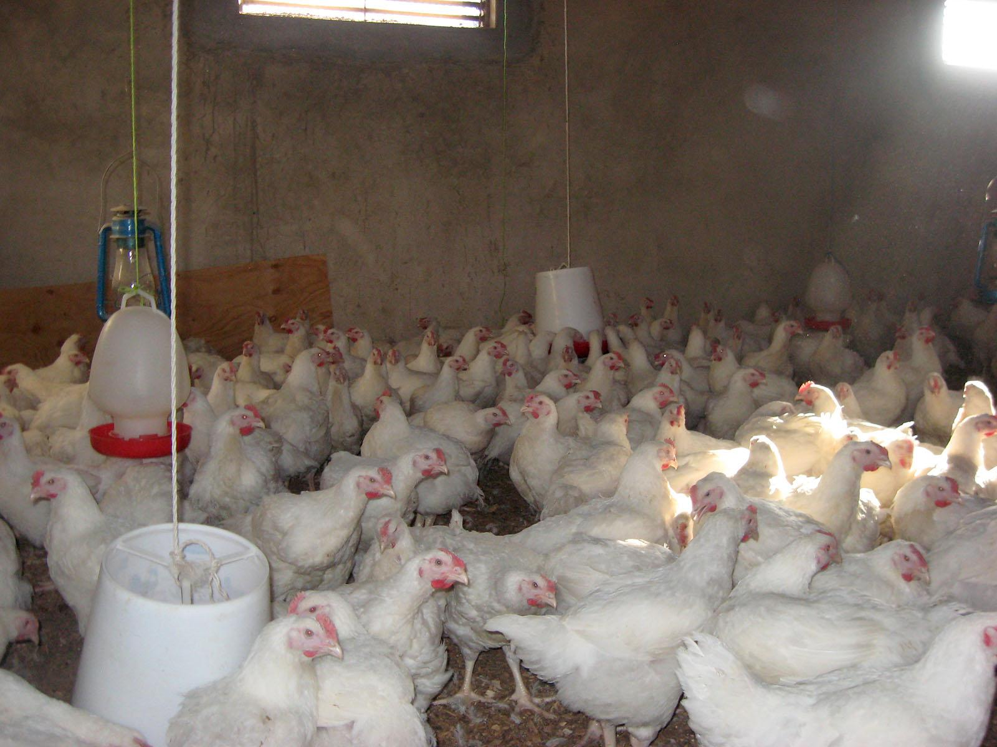
Figure 1. Chickens in a poultry habitat. mcf-poultry-farming-2 by Mully Children's Family is licensed under CC BY-NC-ND 2.0.
Examples of structural biosecurity include the proper cleaning and maintenance of animal pens and equipment. Regular cleaning and maintenance of stables, coops, fences, milking equipment, and feeding areas, among other examples, help protect the animals. Maintaining the facilities protects the animals by keeping them free of injuries and removing potential vectors that could spread disease.
Creating standard procedures for personnel and livestock activities also helps secure the farm. Bacteria, viruses, parasites, and fungi can be easily transported to and from the farm by the people who work there and the animals that live there. New additions to the herd or flock may already be sick, and employees may unknowingly have some sort of pathogen hidden in the mud on their boots. This is why procedures like quarantines for new animals and washing stations for visitors are important. Depending on the farm, there may be special protocols to follow. For example, poultry farms are particularly susceptible to diseases like strains of the bird flu. So visitors and employees may be asked to wear booties on their shoes and a sanitation suit like you would see in a laboratory.
Figure 2. A woman in a clean suit. "Dress like a scientist in our clean suits (19889555815)" by Science and Technology Facilities Council is licensed under CC BY-SA 2.0.

Biosecurity in Plant Science
Like people and animals, plants can catch diseases. For example, cedar-apple rust is a common fungus that can cause damage to apple trees. Cedar-apple rust is spread by the wind from tree to tree. However, other diseases, including blights and rots, which can also be caused by bacteria or fungi, can be spread through insects, soil, animals, and water. While animals can be moved away from areas infected with pathogens or pests, plants usually cannot. This means pests like nematodes and insects like armyworms need to be managed carefully.
Farms often use similar structural and operational strategies to ensure biological risks are managed. Structural strategies may include using a fence, greenhouse, or barn to separate fields, herds, or equipment. Operational strategies may include cleaning equipment between uses to prevent the spread of soil carrying diseases and pests.
Plant biosecurity needs to consider invasive species as well. Invasive species, which use the same methods of transmission as native species, may have fewer natural enemies or resistance to standard control measures. Japanese cedar-apple rust, for example, is a disease caused by an invasive fungus. The disease behaves very similarly to the native cedar-apple rust, but it spreads easier on different trees. Controlling Japanese cedar-apple rust requires different procedures than previously needed, such as changing what trees should be planted near each other.
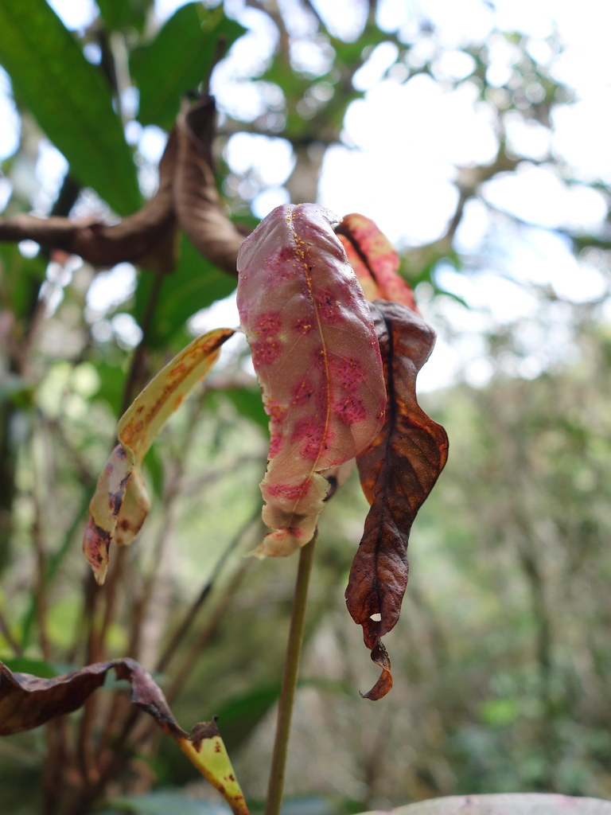
Figure 3. Apple rust-infected leaf. "Rose apple rust caused by Puccinia psidii" by Plant pests and diseases is marked with CC0 1.0.
Another example of a biosecurity procedure in plant science is the effort to combat the spotted lanternfly. The spotted lanternfly is an invasive insect species from China and is a serious threat to Virginia’s fruit and tree industries. The Virginia Department of Agriculture and Consumer Services has been implementing procedures like quarantines to limit the spread. Other measures include setting up a monitoring program and encouraging everyone to kill the insect if they see it.
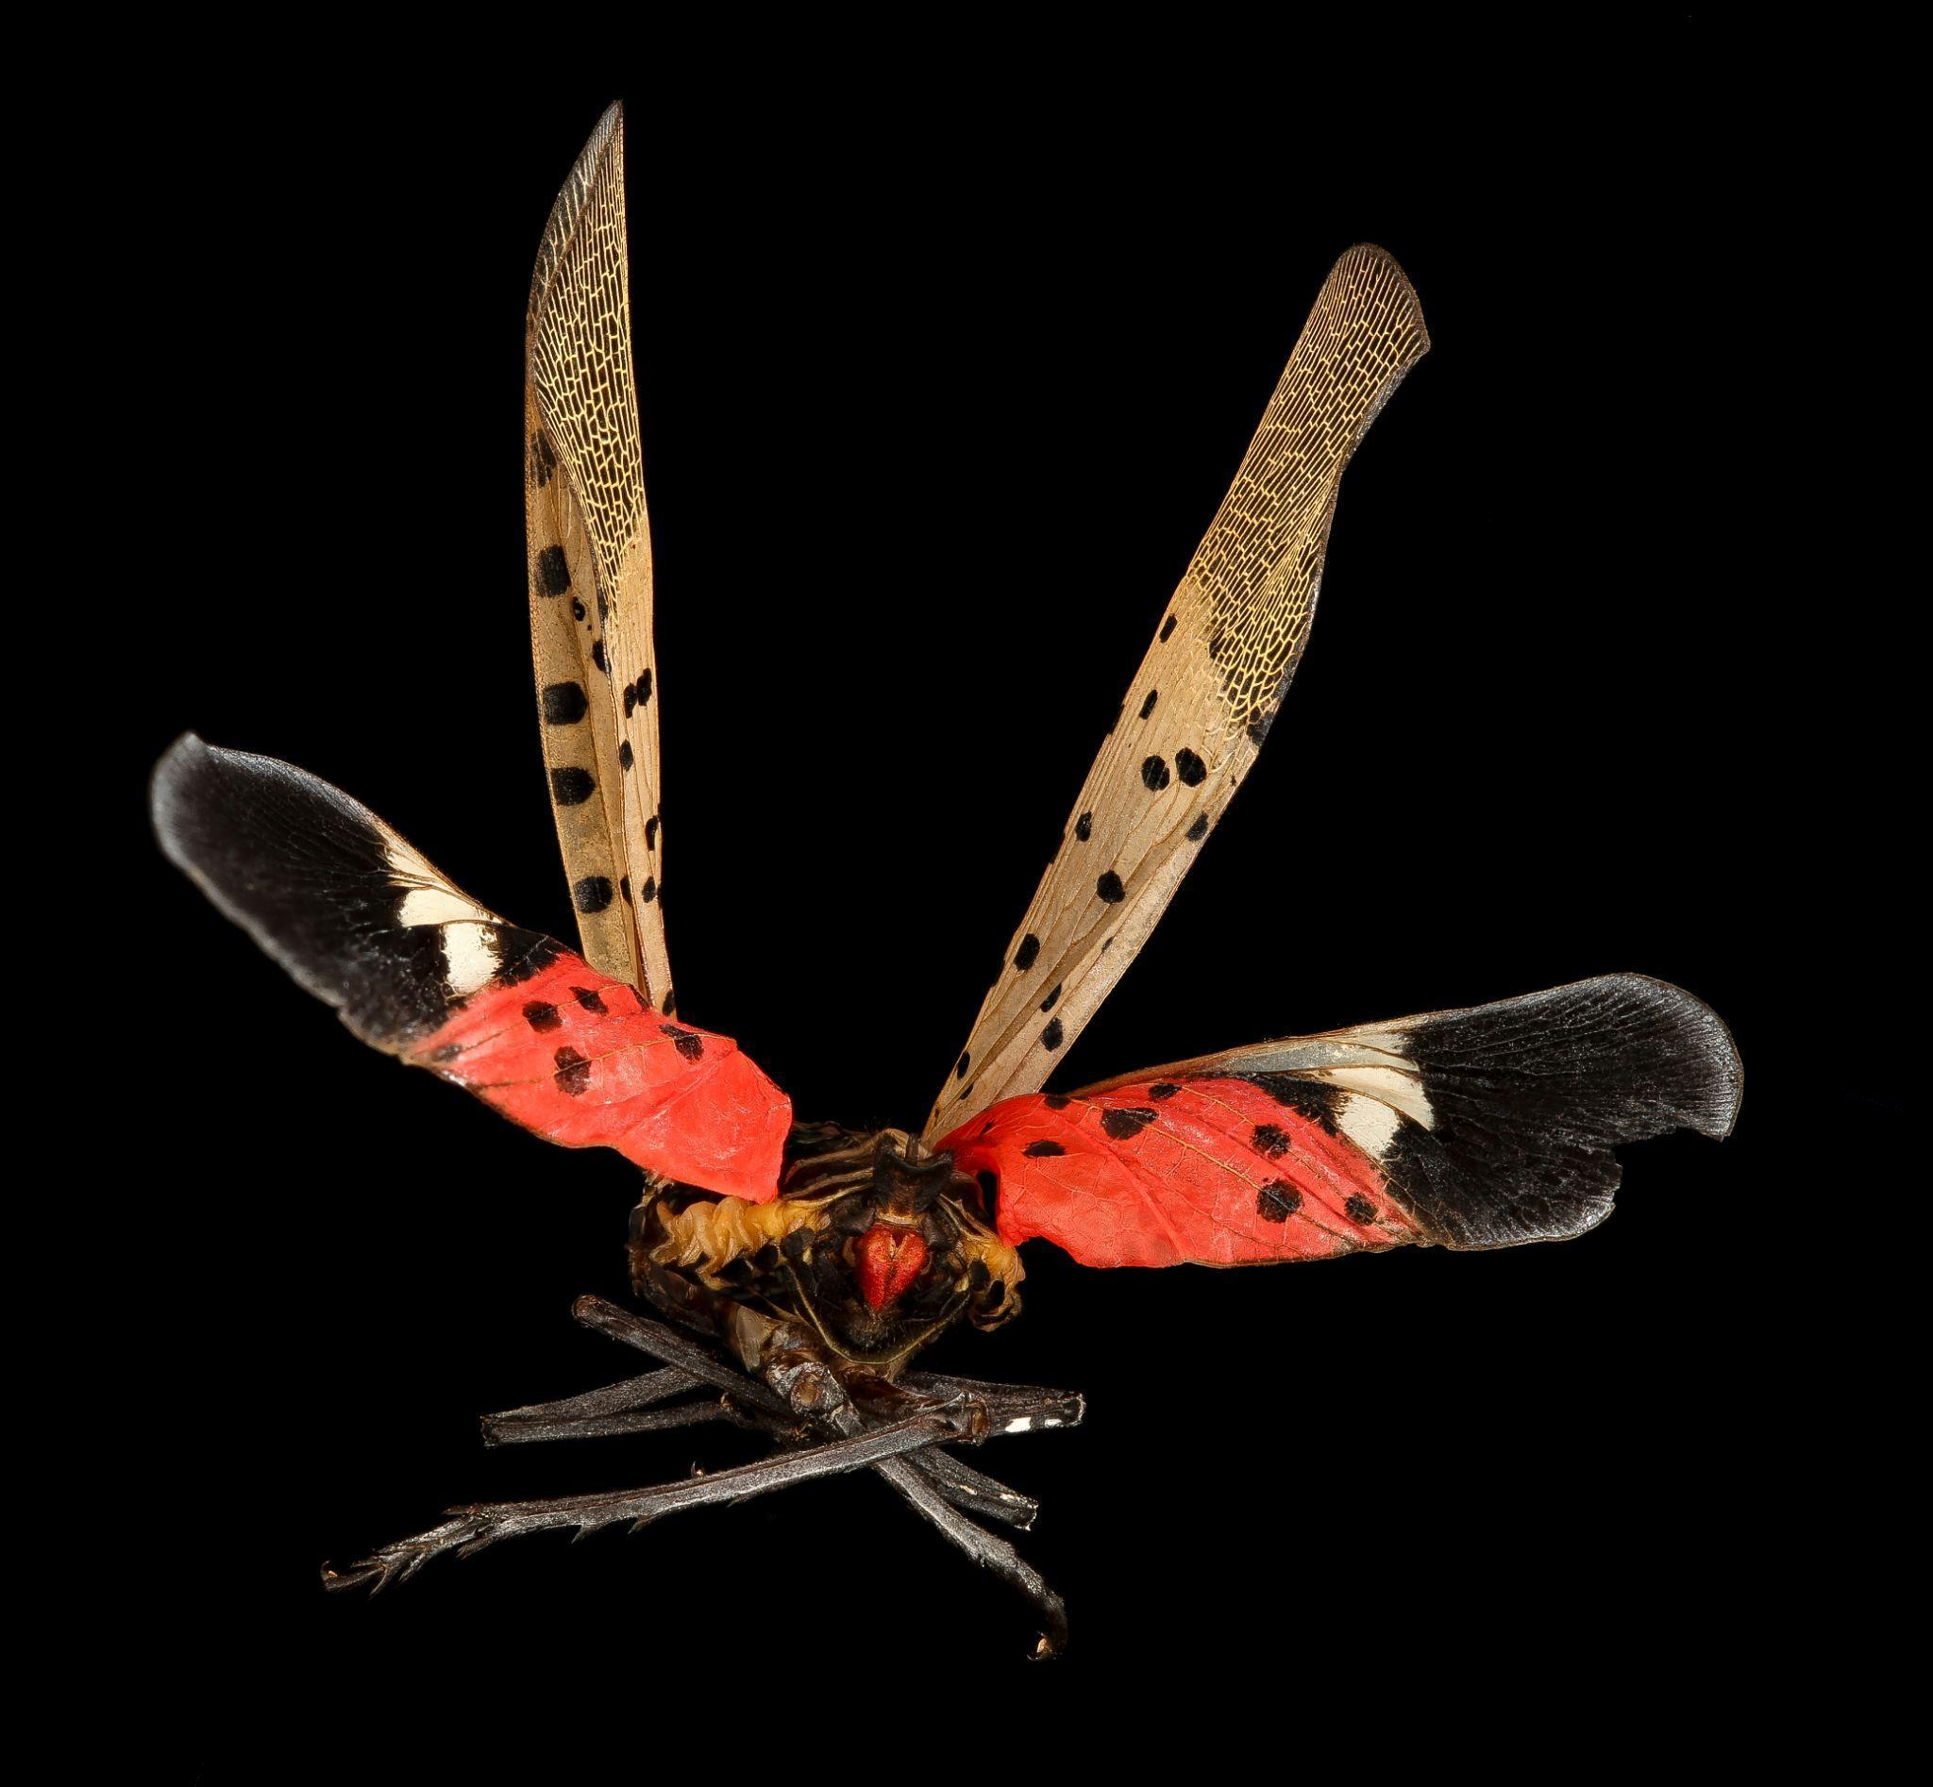
Figure 4. A flying spotted lanternfly. "Spotted Lanternfly, back_2017-06-16-16.50" by Sam Droege is marked with Public Domain Mark 1.0.

Laboratory Biosecurity

Laboratory biosecurity is focused on preventing the release of biomaterials in a laboratory setting. Laboratories all around the world work with pathogens to better understand how to combat them. This includes viruses like the flu, Japanese cedar-apple rust, and even national security interests like anthrax.

While some threats are worse than others, laboratories introduce structural and procedural measures to prevent the spread of these pathogens. Structural measures may include fences, limited access areas, data encryption, and a variety of passwords and key codes to enter the facility. Procedural biosecurity efforts include using personal protective equipment like gloves, hazmat suits and goggles, clearance and approval processes, and appropriate storage of dangerous chemicals. All of these biosecurity measures will vary in importance depending on the type of work completed in the laboratory.

Link to Cyberbiosecurity
As the world becomes more digital, the gap between biosecurity and cybersecurity is becoming narrower. Tasks that were once conducted by a technician in a lab are now automated and run by computers. The use of computers, artificial intelligence, and advanced algorithms in labs means that there is more data than ever to protect and more points for cyber-physical attacks. The same is true on the farm. As automation and digital processes become more common, there is a greater chance for errors to go unnoticed or for malicious actors to disrupt operations. Considering cyberattacks and their impacts on biosecurity is an important approach to strengthening security. Cyberbiosecurity can help fill the small gap between biosecurity, cybersecurity, and cyber-physical security.

Glossary
Artificial intelligence: Advanced computer systems that can perform tasks equally well or surpass that of human intelligence.
Cyber-physical attacks: A security breach that occurs in cyberspace but has influence in the real world, e.g., a hacker turning off a machine.
Invasive plants and animals: A nonnative organism, such as a plant or insect, that causes ecological or economic harm to a region.
Strains: A variety of bacteria. A recent example is the COVID-19 strains, which include Omicron, Delta, and Alpha, among others.
Vectors: An organism that spreads disease, parasites, or other harmful pathogens to another organism.

Additional Resources
Westendorf, M. (2018, April 13). What is Biosecurity? American Farm Publications https://americanfarmpublications.com/what-is-biosecurity-animal-science-update/
U.S. Food and Drug Administration. (2021, April 06). FDA Releases Investigation Report Following Fall 2020 Outbreak of E. Coli Illnesses Linked to Leafy Greens. https://www.fda.gov/news-events/press-announcements/fda-releases-investigation-report-following-fall-2020-outbreak-e-coli-o157h7-illnesses-linked-leafy
Morava, M., & Andrew, S. (2021, March 17). Buckle up. Murder hornet season is around the corner. CNN. https://www.cnn.com/2021/03/17/us/asian-giant-hornet-season-2021-trnd/index.html
The Nature Conservancy. (2019, August 09). Kudzu: The Invasive Vine that Ate the South. https://www.nature.org/en-us/about-us/where-we-work/united-states/indiana/stories-in-indiana/kudzu-invasive-species/

References
Animal and Plant Health Inspection Service. (2021, April 25). Defend the Flock - Biosecurity 101. https://www.aphis.usda.gov/aphis/ourfocus/animalhealth/animal-disease-information/avian/defend-the-flock-program/dtf-biosecurity.
Iowa State University College of Veterinary Science. (2022). Farm Biosecurity. Edu. CFSPH.
Koetter, R., & Michelle G. (n.d.). Cedar-Apple Rust and Related Rust Diseases. University of Minnesota Extension. https://extension.umn.edu/plant-diseases/cedar-apple-rust
National Institute of Food and Agriculture. (2012). History of Agricultural Biosecurity at NIFA. Gov. National Institute of Food and Agriculture. http://www.nifa.usda.gov/grants/programs/agricultural-biosecurity/history-agricultural-biosecurity-nifa
U.S. Department of Health and Human Services. (n.d.). Biosecurity Resources. Gov. Science Security Safety. https://www.phe.gov/s3/BioriskManagement/biosecurity/Pages/Biosecurity-Resources.aspx
Virginia Department of Agriculture and Consumer Services. (n.d.). Spotted Lanternfly (Lycorma Delicatula). https://www.vdacs.virginia.gov/plant-industry-services-spotted-lanternfly.shtml
About the authors
This resource was developed by faculty and students at Virginia Tech: David Smilnak, Ph.D. Candidate in the Department of Agricultural, Leadership, and Community Education; Rebekah Miller, Ph.D. Student in the Department of Food Science and Technology; Jaylan Day, Undergraduate Student in the Department of Chemistry; and Dr. Hannah Scherer, Associate Professor and Extension Specialist in the Department of Agricultural, Leadership, and Community Education, Virginia Tech.

Acknowledgments
This resource was developed, in part, with the help and expertise of the Center for Advanced Innovation in Agriculture (CAIA) through a CAIA-Graduate Student Association writing workshop held in 2022. Jordan Wilson contributed to an earlier version of this work.

This work was supported, in part, through the CCI Southwest Virginia Node Cyberbiosecurity Seed Grant program and the USDA National Institute of Food and Agriculture, Women and Minorities in Science, Technology, Engineering, and Mathematics Fields (WAMS) Grants Program, award #2020-38503-31950. Technical and publishing support was provided by the Open Education Initiative of the University Libraries at Virginia Tech.

About this project
Cyberbiosecurity is an emerging field that focuses on creating security measures for digital aspects of our food and agriculture systems, creating a structure and opportunity for a safe food system that can meet the large needs of a growing population and world. This educational resource was developed as part of a project to support formal and non-formal agricultural educators in integrating cyberbiosecurity topics and research-based strategies for engaging middle-school-aged girls in STEM into their educational programs.

The entire resource collection can be accessed here: https://doi.org/10.21061/cyberbiosecurity

The project is an outreach effort of the Virginia Tech Center for Advanced Innovation in Agriculture.

Did you know that you can customize and share your version of this Open Educational Resource?
This resource is licensed with a Creative Commons Attribution-NonCommercial-ShareAlike 4.0 license. This means you are free to copy, share, adapt, remix, transform, and build on the material for any primarily noncommercial purpose as long as you follow the terms of the license: https://creativecommons.org/licenses/by-nc-sa/4.0. Best practice for attribution is to list the title, author, source, and license.

