Biotechnology

Agricultural Cyberbiosecurity

Agricultural Cyberbiosecurity

## Key terms

* **Biomanufacturing:** A process that produces commercially relevant biological materials.
* **Gene:** A collection of DNA found in chromosomes that controls what characteristics are passed on to a person, animal, or plant.
* **Genetic diversity:** the total number of genetic traits possible in a population of organisms.

## Agricultural Biotechnology

In agriculture, **biotechnology** looks like **genetically modified** plants and animals. That means, scientists can make changes to the **DNA** of plants or animals, so they develop a certain way. This idea isn’t new. There are many types of apples. This is because we liked certain things about certain apples. Farmers selected those apples over others because their customers liked them more. Today, scientists can select specific **genes**. Scientists can pick genes to keep plants and animals healthy and increase the amount of food produced.

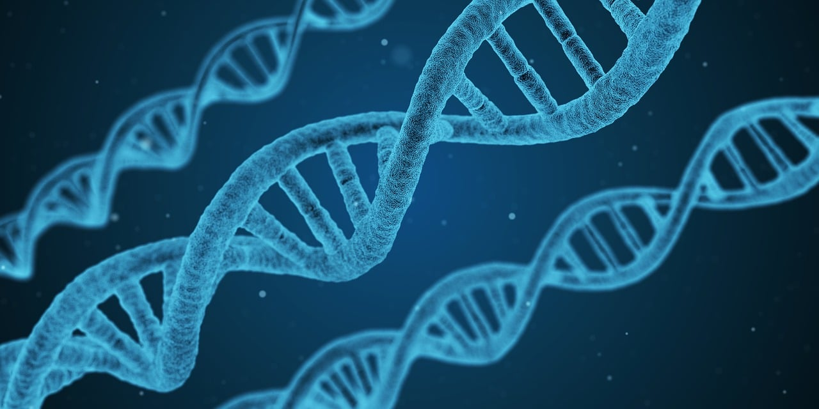

**DNA Helix String**

royalty-free stock illustration *by qimono via [Pixabay](https://pixabay.com/)*. Free for use and download via Pixabay Content License.

## What is Biotechnology?

Biotechnology includes new tools that were inspired by living things. We see examples of biotechnology in farming, manufacturing, and in medicine. This is very similar to biomanufacturing, but biotechnology focuses on specific tools. In these areas, biotechnology helps us change genes in living things to make them better. We can change genes to help plants grow better or to help people with genetic diseases. Each area of biotechnology does things a little bit differently.

## Industrial Biotechnology

**Industrial biotechnology**, sometimes called **biomanufacturing**, helps us make chemicals, energy, and materials. It can do this by using processes we find in nature and using them to help us. One example is cheese! Cheese starts out as milk, but how does it become cheese? Well, bacteria **ferment** it. **Fermentation** is a process in which bacteria, fungi, or yeast eat some chemicals and make them hotter. The bacteria make the milk hotter and make new chemicals, which turn the milk into cheese. A similar thing happens to bread and yogurt.

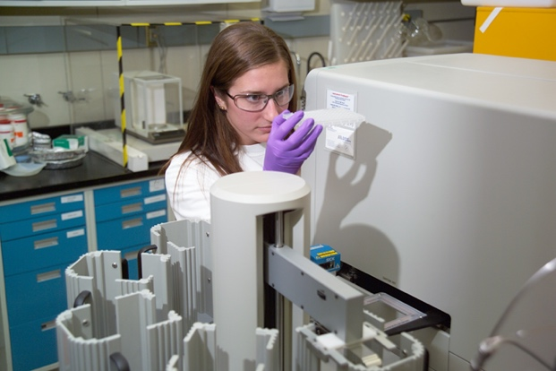

## Medical Biotechnology

**Medical biotechnology** is like **industrial biotechnology**, but it focuses specifically on medicine. For example, we see fungi, like mushrooms, all the time. Well, some of these fungi can protect themselves from bacteria. This is just something they can do on their own. Some scientists thought the fungi might be able to help us too. By studying how the fungi protect themselves we can create medicine. This is how we got penicillin.

"[Biotechnology](https://www.flickr.com/photos/30369883@N03/3637156598)" by [Idaho National Laboratory](https://www.flickr.com/photos/30369883@N03) is licensed under [CC BY 2.0](https://creativecommons.org/licenses/by/2.0/?ref=openverse).

## Connection

## to Cyberbiosecurity

Biotechnology can do some amazing things. A lot of those things we will eventually eat. This includes our lunches today, or medicines we take when we are sick. While most of the processes come from nature, we usually recreate the processes in a lab or factory. Those factories are run by computers. Making sure those computers stay protected is very important. If those computers are not working right, some people could get sick. Having people in charge of keeping those computers safe, keeps us safe too!

CAIA

Scientist Spotlight

## Career connections

Computer Science

Agriculture

Biotechnology

Engineering

Medicine

Operation management

Biology

Chemistry

Did you know? The College of Agriculture and Life Sciences at Virginia Tech has nearly 70 program options! Find your career connections at [cals.vt.edu](https://www.cals.vt.edu/) or email [applytoCALS@vt.edu](mailto:applytoCALS@vt.edu)

***Sabrina Amorim*** is an Animal Scientist with Master’s of Science in Genetics and Animal Breeding, and currently a Ph.D. Student in the [School of Animal Sciences](https://nam04.safelinks.protection.outlook.com/?url=https%3A%2F%2Fsas.vt.edu%2Findex.html&data=05%7C01%7Chscherer%40vt.edu%7C6972726d4b594d6f24fd08dba8ac0311%7C6095688410ad40fa863d4f32c1e3a37a%7C0%7C0%7C638289228967770054%7CUnknown%7CTWFpbGZsb3d8eyJWIjoiMC4wLjAwMDAiLCJQIjoiV2luMzIiLCJBTiI6Ik1haWwiLCJXVCI6Mn0%3D%7C3000%7C%7C%7C&sdata=ak8ohvUF1lOfsQ7pWsGBflAM0gwK47CG9wEBLYH9G3M%3D&reserved=0) at Virginia Tech. Her research interest includes quantitative genetics and image analyses of high-throughput phenotyping data. She is interested in better understanding the genetic architecture of economically important traits in livestock and applying and developing ways to use statistics to predict the occurrence of traits. Sabrina is a CAIA Graduate Student Affiliate.

Alliance for Science. (2015, January 23). *Learn About How Public-Sector Scientists Saved Papaya.* https://allianceforscience.cornell.edu/blog/2015/01/learn-about-how-public-sector-scientists-saved-papaya/

ISAAA. (2014). Agricultural Biotechnology (A Lot More Than Just GM Crops). https://www.isaaa.org/resources/publications/agricultural_biotechnology/download/default.asp

Ledford, H., & Callaway, E. (2020). Pioneers of revolutionary CRISPR gene editing win the Chemistry Nobel. *Nature, 586*(7829), 346–347. https://doi.org/10.1038/d41586-020-02765-9

Murch, R. S., So, W. K., Buchholz, W. G., Raman, S., & Peccoud, J. (2018). Cyberbiosecurity: An Emerging New Discipline to Help Safeguard the Bioeconomy. *Frontiers in Bioengineering and Biotechnology, 6*, 39. https://doi.org/10.3389/fbioe.2018.00039

USDA. (n.d.). *Biotechnology FAQs*. https://www.usda.gov/topics/biotechnology/biotechnology-frequently-asked-questions-faqs

Western Governors University. (2021, January 29). *Medical Biotechnology: Advancement and Ethics.* https://www.wgu.edu/blog/medical-biotechnology-advancements-ethics1811.html

Zhang, Y. H. P., Sun, J., & Ma, Y. (2017). Biomanufacturing: History and Perspective. *Journal of Industrial Microbiology and Biotechnology, 44*(4–5), 773–784. <https://doi.org/10.1007/s10295-016-1863-2>

References

**This resource is presented on a template developed by Kindred Grey. How to cite this template:**

Adapted by Kindred Grey from “Agricultural Cyberbiosecurity” by David Smilnak, Anne Brown, Joseph Simpson, Jaylan Day, and Hannah Scherer from <https://doi.org/10.21061/cyberbiosecurity>. [CC BY-NC-SA 4.0](https://creativecommons.org/licenses/by-nc-sa/4.0/). Includes [Beaker by IYIKON](https://thenounproject.com/icon/beaker-1071399/), [Computer by uzeir syarief](https://thenounproject.com/icon/computer-1417082/), [Factory by kareemov1000](https://thenounproject.com/icon/factory-1175017/), [Microscope by Ariyanto Deni](https://thenounproject.com/icon/microscope-4831959/), [Poison by Muhammad Atiq](https://thenounproject.com/icon/poison-4648765/), [Science by Soremba](https://thenounproject.com/icon/science-5518906/), [Scientist by Amethyst Studio](https://thenounproject.com/icon/scientist-4135259/), [Test tubes by Blaise Sewell](https://thenounproject.com/icon/test-tubes-2809670/), and [Tractor by Olivier Guin](https://thenounproject.com/icon/tractor-1192/), all from the Noun Project ([CC BY 4.0](https://creativecommons.org/licenses/by/4.0/)).

*This project is an outreach effort of the Virginia Tech Center for Advanced Innovation in Agriculture.* This work is supported, in part, through the CCI Southwest Virginia Node Cyberbiosecurity Seed Grant program and the USDA National Institute of Food and Agriculture, Women and Minorities in Science, Technology, Engineering, and Mathematics Fields (WAMS) Grants Program, award #2020-38503-31950.

This factsheet was partially created through the use of ChatGPT, a large language model artificial Intelligence. ChatGPT was given reference material found in a ~12th grade reading level version, and prompted with, "convert to a 6th grade reading level" before additional edits from the authors.

**This resource was developed by faculty and students at Virginia Tech:**

David Smilnak*, Ph.D. Student, Department of Agricultural, Leadership, and Community Education*

Sabrina Amorim, *Ph.D. Student, Department of Animal and Poultry Science*

Jaylan Day*, Undergraduate Student, Department of Chemistry*

Madison Powell*, Undergraduate Student, Department of Agricultural, Leadership, and Community Education*

Emily Mullins*, Undergraduate Student, Department of Agricultural, Leadership, and Community Education*

Hannah Scherer, *Associate Professor and Extension Specialist, Department of Agricultural, Leadership, and Community Education*

Acknowledgements

**What is an open educational resource?**

The idea behind Open Educational Resources (OER) is simple but powerful—educational materials made freely and legally available on the Internet for anyone to reuse, revise, remix and redistribute. These digital materials have the potential to give people everywhere equal access to our collective knowledge and provide many more people around the world with access to quality education by making lectures, books, and curricula widely available on the Internet for little or no cost.

This definition of OER is provided by [The William and Flora Hewlett Foundation](http://www.hewlett.org/programs/education/open-educational-resources).

**How to access these templates**

The main landing page for these resources is <https://doi.org/10.21061/cyberbiosecurity>.

This page includes a downloadable and editable Word document for the:

* Student fact sheet
* Student activity sheet
* Facilitator’s guide

What is an Open Educational Resource?

**How to cite this version**

Smilnak, David, Sabrina Amorim, Jaylan Day, Madison Powell, Emily Mullins, and Hannah Scherer (2023). *Agricultural Cyberbiosecurity: Biotechnology.* <https://doi.org/10.21061/cyberbiosecurity>. Licensed with CC BY-NC-SA 4.0 <https://creativecommons.org/licenses/by-nc-sa/4.0>.

**Did you know that you can customize and share your version of this resource?**

This resource is licensed with a Creative Commons Attribution-NonCommercial-ShareAlike 4.0 license. This means you are free to copy, share, adapt, remix, transform, and build on the material for any primarily noncommercial purpose as long as you follow the terms of the license:<https://creativecommons.org/licenses/by-nc-sa/4.0>.

*Best practice is to list the title, author, source, and license.

Example: Adapted by [your name] from “Agricultural Cyberbiosecurity: Big Data” by David Smilnak, Anne Brown, Joseph Simpson, Jaylan Day, and Hannah Scherer from <https://doi.org/10.21061/cyberbiosecurity>. [CC BY-NC-SA 4.0](https://creativecommons.org/licenses/by-nc-sa/4.0/).

