Precision Agriculture
Agricultural Cyberbiosecurity Education Resource Collection
Authored by David Smilnak, Shannon Bradley, and Dr. Hannah Scherer

Introduction

Have you ever considered a job as a drone pilot? Do you enjoy turning your house into a smart house? Have you thought about trying to protect the data and programs involved with both? Have you ever considered combining that with farming? It might sound funny at first, but farming is quickly becoming very high-tech. Farmers aren’t just planting crops or tending to their cows. Now they use drone-mounted thermal cameras to see how healthy crops are, GPS trackers to keep tabs on cows, and phone apps to drive tractors. All of this is being done to make farming more cost-effective and environmentally friendly.
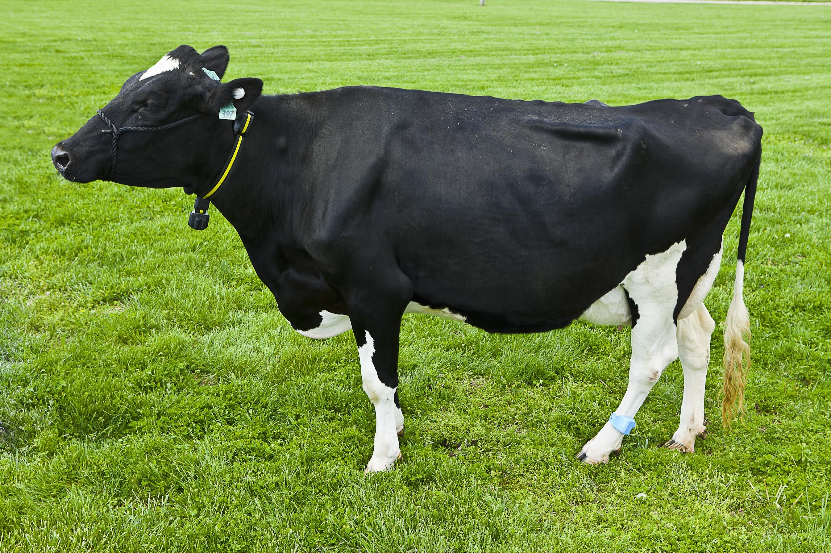
Figure 1. A cow with a GPS and health sensor on its collar. "20110429acp115sp008p" by ukagriculture is licensed under CC BY-NC-ND 2.0.

A Brief History of Precision Agriculture
Precision agriculture gets its name from farmers trying to be “precise” with the amount of fertilizer, pesticides, and water used. While it might seem like a new idea, precision agriculture can trace its roots back to the 1980s. In its most basic form, precision agriculture means changing the amount of fertilizer, pesticide, water, etc. put on a field based on the needs of the particular plant or piece of land. This can be done by hand by changing the equipment. Quickly, though, this started to become more automated. In fact, the first remote-controlled agricultural drone was used in the 1980s to spray rice paddies.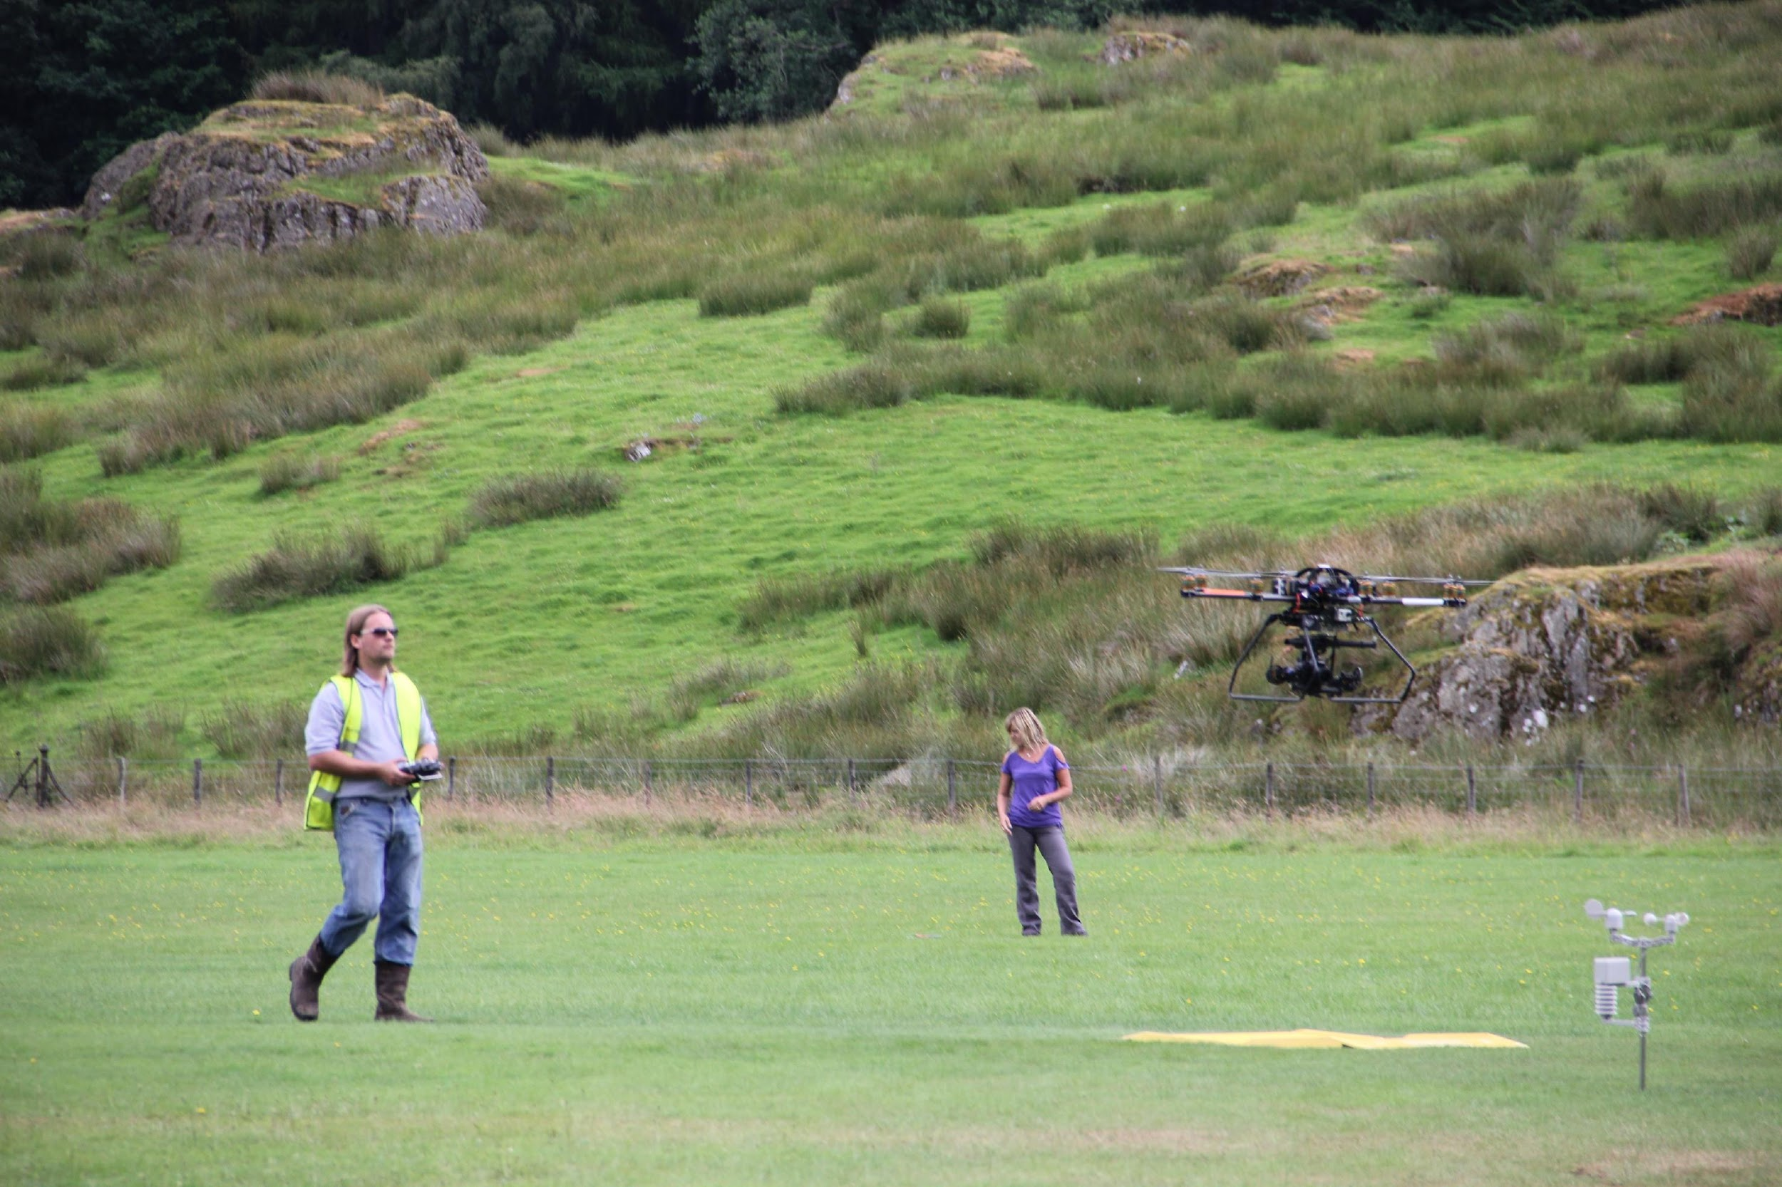
Figure 2. Drone pilots testing their agricultural drone. "Drone test flight" by millstastic is licensed under CC BY 2.0.

Modern Precision Agriculture
Since the 1980s, precision agriculture has become more technological. Companies like John Deere and New Holland among others have tried to automate as much farm work as possible. While this helps farmers make precise adjustments to their equipment, it also makes the equipment more computer-driven. Today, with internet connectivity and the Internet of Things (IoT), all of these processes are becoming interconnected. Farmers do not even need to be on the tractor anymore. They can set a tractor’s path on the computer, and with a combination of sensors in the field and GPS, the tractor knows where to go and what to do. Oftentimes, a farmer can make management decisions from their phone. From moving digital fences that corral their cows to turning on their irrigation system, farmers have a wide range of technological farming equipment at their disposal. 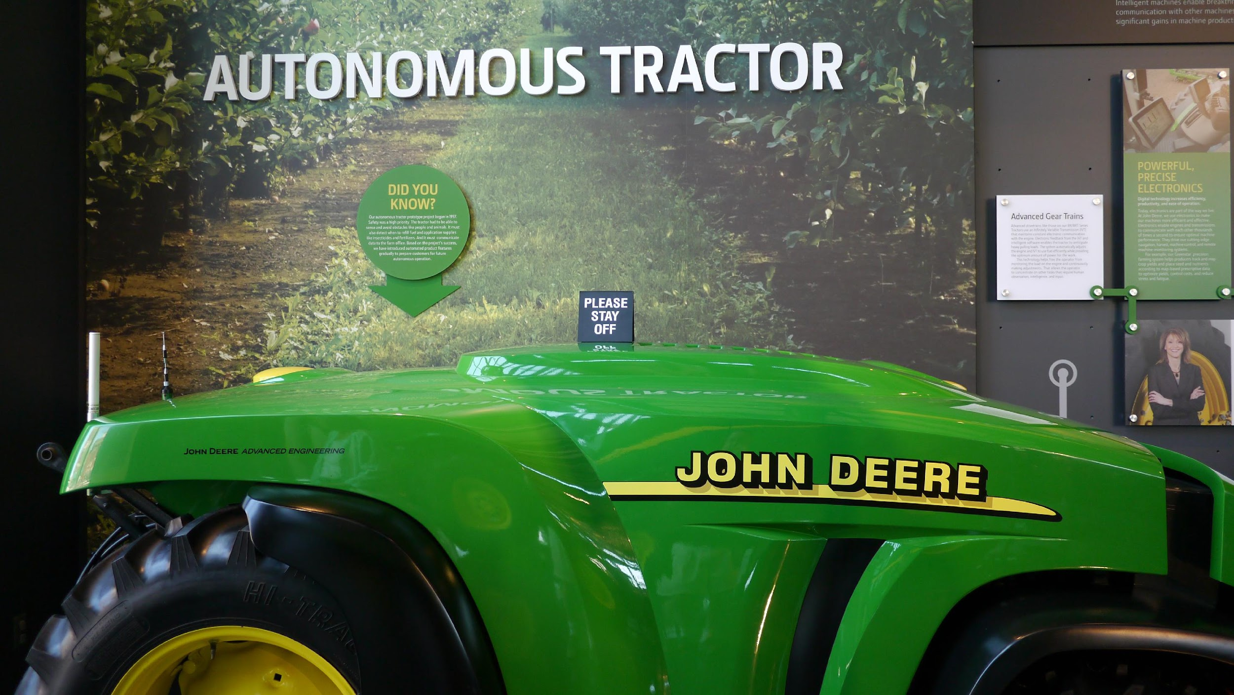
Figure 3. An autonomous tractor produced by John Deere. "Our Future" by adamthelibrarian is licensed under CC BY-NC-SA 2.0.
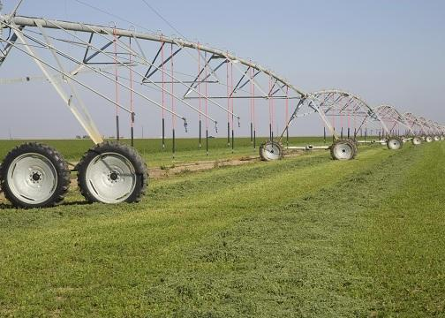
Figure 4. A center pivot irrigation system. "Center Pivot Irrigation System" by eutrophication&hypoxia is licensed under CC BY 2.0.

Connection to Cyberbiosecurity

With all of this technology, however, there are some risks. When you are online, you need to be careful about the sites you visit and who you talk to. If not, you open yourself up to phishing scams, ransomware, and other risks. Farmers have the same issue now. There are many aspects that farmers today have to be careful with, including the data they create, their internet connectivity, and computer updates for tractors. This overlap between security, agriculture, and technology is referred to as cyberbiosecurity. Cyberbiosecurity is quickly becoming a large part of agriculture. For example, while drones are helpful, they can produce images like the one below that often need to be analyzed by a specialist. Being able to understand what sites and services are trustworthy will become increasingly important for farmers in the future.
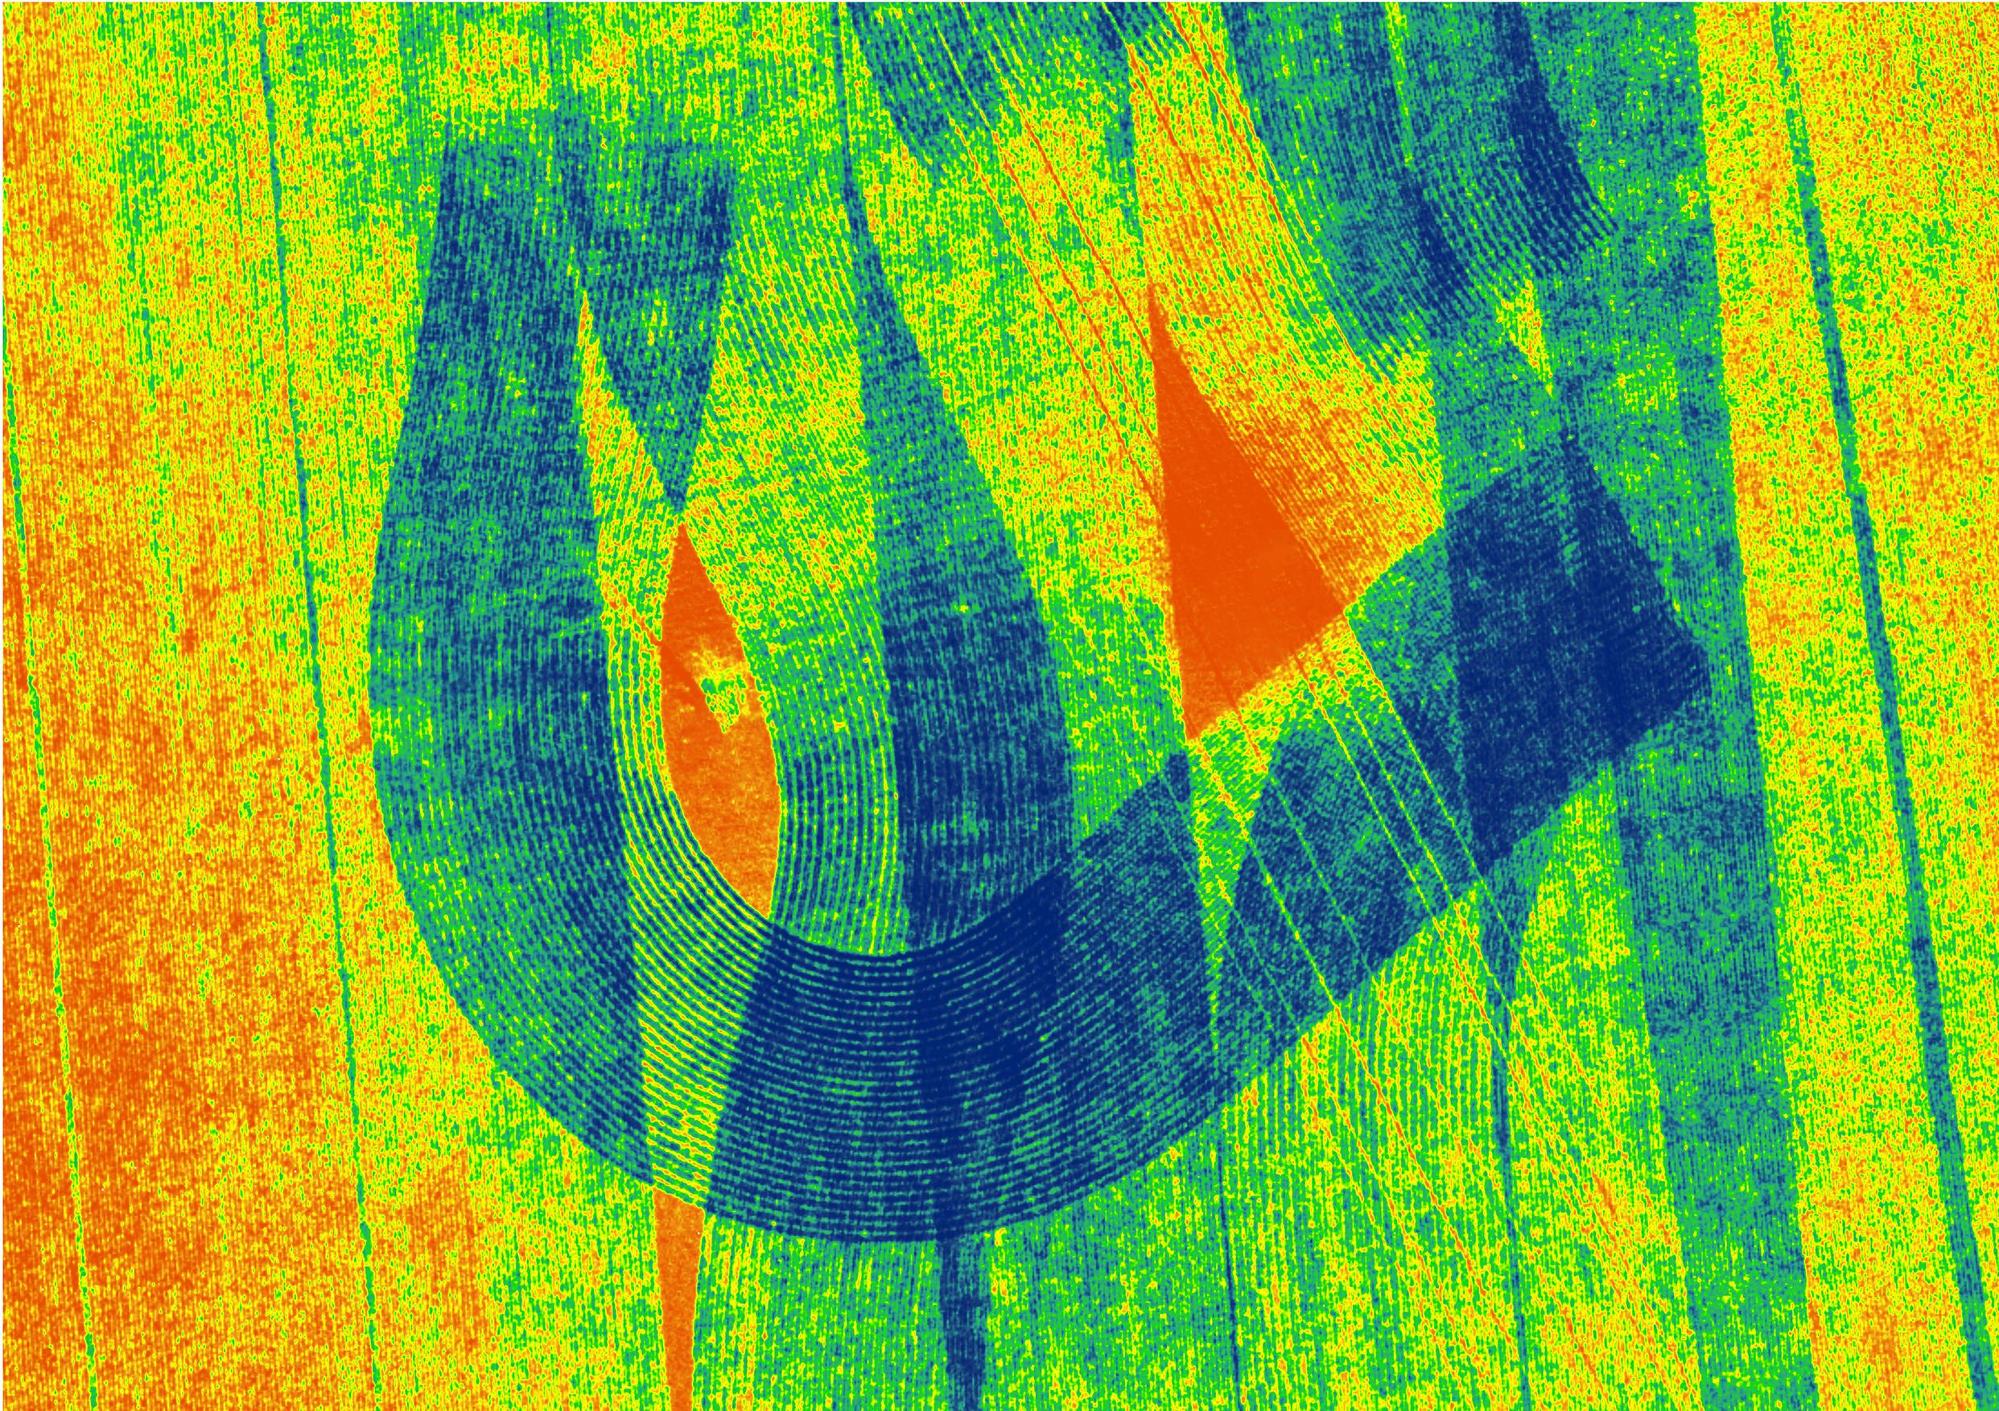
Figure 5. A NDVI “Normalized Difference Vegetative Index” image taken by a drone to show crops that are stressed versus ones that are healthy. "Agricultural art" by Antarsih is licensed under CC BY 4.0

Conclusion

Agriculture has become much more technologically advanced in recent years. Farming relies on Big Data, the Internet of Things, and data literacy to operate large-scale farms today. The average age of a farmer in Virginia is 58. While farmers are learning the basics of digital farming, they did not grow up with the internet like the younger generations. This means that something that comes naturally to those in middle school now, like flying drones, setting up smart devices, and being safe on the internet, may not be as easy for some farmers. So, careers in agricultural data analytics, remote sensing, and tractor technicians need professionals skilled in computer science and agricultural science to help our farmers keep their farms safe and food on our tables.

Glossary
Big Data: Data sets that are increasingly large and complex, in which we can find helpful trends that would otherwise not be apparent.
Data Literacy: The ability to read, work with, analyze, and communicate measures or records in context.
Internet of Things: The connectivity between different computers, sensors, products, and processes via the internet.
Phishing Scam: A type of online scam that targets consumers by sending them an e-mail that appears to be from a well-known source—an internet service provider, a bank, or a mortgage company.
Ransomware: a type of malicious software designed to block access to a computer system until a sum of money is paid.

References
Coble, K. H., Mishra, A. K., Ferrell, S., & Griffin, T. (2018). Big Data in Agriculture: A Challenge for the Future. Applied Economic Perspectives and Policy, 40(1), 79–96. https://doi.org/10.1093/aepp/ppx056
Erickson, B., Fausti, S., Clay, D., & Clay, S. (2018). Knowledge, Skills, and Abilities in the Precision Agriculture Workforce: An Industry Survey. Natural Sciences Education, 47(1), 1–11. https://doi.org/10.4195/nse2018.04.0010
Griffin, E., Ledbetter, A., Sparks, G., & Langan, E. (2021). A First Look at Communication Theory (10th Edition). https://www.afirstlook.com/edition-10/theory-resources/by-theory/Media-Multiplexity-Theory/overview
Lowenberg‐DeBoer, J., & Erickson, B. (2019). Setting the Record Straight on Precision Agriculture Adoption. Agronomy Journal, 111(4), 1552–1569. https://doi.org/10.2134/agronj2018.12.0779
Osinga, S. A., Paudel, D., Mouzakitis, S. A., & Athanasiadis, I. N. (2022). Big data in agriculture: Between opportunity and solution. Agricultural Systems, 195, 103298. https://doi.org/10.1016/j.agsy.2021.103298
Rotz, S., Duncan, E., Small, M., Botschner, J., Dara, R., Mosby, I., Reed, M., & Fraser, E. D. G. (2019). The Politics of Digital Agricultural Technologies: A Preliminary Review. Sociologia Ruralis, 59(2), 203–229. https://doi.org/10.1111/soru.12233
Sheets, K. D. (2018). The Japanese Impact on Global Drone Policy and Law: Why a Laggard United States and Other Nations Should Look to Japan in the Context of Drone Usage. Indiana Journal of Global Legal Studies, 25(1), 513. https://doi.org/10.2979/indjglolegstu.25.1.0513
Shekhar, S., Schnable, P., LeBauer, D., Baylis, K., & VanderWaal, K. (2017). Agriculture Big Data (AgBD) Challenges and Opportunities from Farm to Table: A Midwest Big Data Hub Community Whitepaper. Whitepaper for the US National Institute of Food and Agriculture.
About the authors
This resource was developed by faculty and students at Virginia Tech: David Smilnak, Ph.D. Candidate in the Department of Agricultural, Leadership, and Community Education; Shannon Bradley, Graduate Student in the Department of Entomology; Dr. Hannah H. Scherer, Associate Professor and Extension Specialist in the Department of Agricultural, Leadership, and Community Education.

Acknowledgments
This resource was developed, in part, with the help and expertise of the Center for Advanced Innovation in Agriculture (CAIA) through a CAIA-Graduate Student Association writing workshop held in 2022. Jordan Wilson contributed to an earlier version of this work.

This work was supported, in part, through the CCI Southwest Virginia Node Cyberbiosecurity Seed Grant program and the USDA National Institute of Food and Agriculture, Women and Minorities in Science, Technology, Engineering, and Mathematics Fields (WAMS) Grants Program, award #2020-38503-31950. Technical and publishing support was provided by the Open Education Initiative of the University Libraries at Virginia Tech.

About this project
Cyberbiosecurity is an emerging field that focuses on creating security measures for digital aspects of our food and agriculture systems, creating a structure and opportunity for a safe food system that can meet the large needs of a growing population and world. This educational resource was developed as part of a project to support formal and non-formal agricultural educators in integrating cyberbiosecurity topics and research-based strategies for engaging middle-school-aged girls in STEM into their educational programs.

The entire resource collection can be accessed here: https://doi.org/10.21061/cyberbiosecurity

The project is an outreach effort of the Virginia Tech Center for Advanced Innovation in Agriculture.

Did you know that you can customize and share your version of this Open Educational Resource?

This resource is licensed with a Creative Commons Attribution-NonCommercial-ShareAlike 4.0 license. This means you are free to copy, share, adapt, remix, transform, and build on the material for any primarily noncommercial purpose as long as you follow the terms of the license: https://creativecommons.org/licenses/by-nc-sa/4.0. Best practice for attribution is to list the title, author, source, and license.

