Data Literacy
Agricultural Cyberbiosecurity Education Resource Collection
Authored by David Smilnak, Jordan Allen, Jaylan Day, and Dr. Hannah H. Scherer

What is Data?
Data is everywhere and revolves around everything we do. It is used anywhere from choosing the best time to grow crops to finding the cure for a rare disease or even creating personalized Spotify playlists just for you. Data is information gathered by the observation of people, things, or objects and can measure quantities, traits, or characteristics. There are two forms of data: numerical and descriptive. For example, the number of grapes in a bunch is numerical data. In contrast, the color of the grapes is an example of descriptive data. Data is created from information that can be gathered from almost anything, so understanding how to measure data correctly is essential.

Data in Agriculture
Farmers have been relying on data for years to understand and predict environmental conditions such as weather and climate. Over time, farmers use their observations about their land, the local weather, and the time of year to make management decisions for their farms. Recently, the use of technology in agriculture has meant that farmers can collect more data than ever. GPS-equipped tractors and weather tracking are examples of technology that allow agribusinesses to understand when and where to grow crops and if their crops are growing well. Growers can use data and new technologies to increase the efficiency of their processes, which can also boost production and profitability. One of the main reasons is the urgent need to produce more food for the world’s growing population. Using data is one of the ways farmers and agronomists are working to solve this problem.
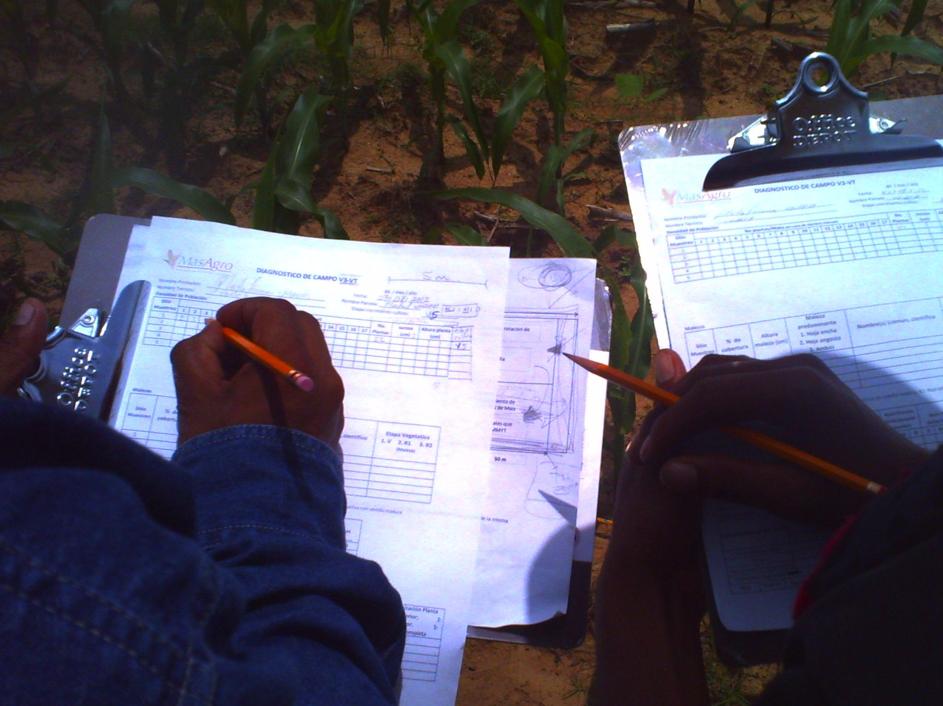
Figure 1: Conservationists recording data on corn. "Conservation agriculture in Chiapas: Data time" by CIMMYT is licensed under CC BY-NC-SA 2.0.

What is Data Literacy?
Data literacy is the ability to understand, read (graphs and charts), create, and communicate data effectively as information. An important component of data literacy is finding value in data. Data analysis is done after data collection to look for information that could explain trends or characteristics. It is frequently used to make important judgments, so it's critical to understand when data is misleading or presenting false information. Since data is commonly shared for public use, it's critical to handle it ethically.

What is Ethical Data?
Did you know that one out of every three sheep has two tails? Did that statistic surprise you? If so, it's likely because this fact is not true. This is an example of unethical data. Data is considered ethical when it is reliable, accurate, and honest. With many resources available online, it's important to always consider the ethics of the content you read. Three main types of research misconduct are related to unethical data:
Fabrication: when data is changed or left out to help support a hypothesis.
Falsification: the addition of data or observations that never happened.
Plagiarism: when you represent other work as your own.
False information has the potential to misinform individuals about critical issues that may have a direct influence on them. It is crucial to gather ethical data, but it is also crucial to recognize when data may be false or unethical.

Data Collection
Have you ever wondered where our data comes from? We’ve discussed some places already, but data is collected in many different ways. Data can be collected through surveys, interviews, personal interactions, mobile devices, sensors, computers, the internet, and observations, among others.
Mobile devices such as cell phones collect an enormous amount of data because of the many apps and additions that can be added to the device. Sometimes this is referred to as Big Data. TikTok, a popular social media app, is an example of an app that collects large amounts of data. One way TikTok collects data is by counting the number of likes someone’s post receives. The app also uses data to collect information about the person using it, such as their ages, gender, and usernames. TikTok also uses data analytics to show the most popular videos on the main screen, known as the “For You” page, and control the content users observe based on their most visited posts.
Big data refers to data that is very large and complex and cannot be summarized using traditional data analysis methods. Instead, big data utilizes different types of software for people to understand the data being collected. Big data makes information on rainfall patterns, soil health, fertilizer needs, and other topics available to farmers. They can use this information to make decisions about when to harvest, what crops to grow, and where to grow specific crops to maximize crop yield.

Types of Data
Traditional forms of data are handwritten, audio, images, videos, or prints. Data can also be converted into a digital format so that a computer can recognize it. Digitized data is also easier to access and share. Cybersecurity and cyberbiosecurity focus on the protection of digitized data and information.
Some digitized data doesn’t exist on a physical object, such as a USB flash drive. Digital data not stored on a physical device is usually held on software called a cloud. Google Drive, OneDrive, and iCloud are examples of cloud data storage. Cloud data storage allows for a quick way to transfer data between devices; however, it can compromise security and access to the data.

Connection to Cyberbiosecurity
Data literacy is a universal concept that isn’t restricted to the field of cyberbiosecurity. In the agricultural industry, understanding and interpreting data is a very marketable skill and one that is vital to the success of a farm or agribusiness. Being able to understand the data and reliably decide if what you’re seeing is trustworthy is going to become more important as digital technology progresses. Data crimes like phishing scams and ransomware can be incredibly harmful. As industries like agriculture become more reliant on digital technology, the opportunity for data crimes to happen increases. Being up-to-date on data literacy also makes sure you know how to protect and use your data.
Glossary
Agronomist: an expert in the science of soil management and crop production.
Big Data: Data sets that are increasingly large and complex, in which we can find helpful trends that would otherwise not be apparent.
Phishing Scam: A type of online scam that targets consumers by sending them an e-mail that appears to be from a well-known source—an internet service provider, a bank, or a mortgage company.
Ransomware: a type of malicious software designed to block access to a computer system until a sum of money is paid.

References
Osinga, S. A., Paudel, D., Mouzakitis, S. A., & Athanasiadis, I. N. (2022). Big data in agriculture: Between opportunity and solution. Agricultural Systems, 195, 103298. https://doi.org/10.1016/j.agsy.2021.103298.

University of Wisconsin. (2021, May 18). What Is Big Data? University of Wisconsin Data Science Degree. https://datasciencedegree.wisconsin.edu/data-science/what-is-big-data/

U.S. General Services Administration. (2022). Agriculture. Gov. Data.Gov. https://www.data.gov/food/

Additional Resources

DATA.GOV Food Resillience Datasets. https://catalog.data.gov/dataset/?vocab_category_all=Food+Resilience

Dvorak, C. (2022, February 22). What Data Does TikTok Collect? Reviews.org. https://www.reviews.org/internet-service/what-data-does-tiktok-collect/
About the authors
This resource was developed by faculty and students at Virginia Tech: David Smilnak, Ph.D. Candidate in the Department of Agricultural, Leadership, and Community Education; Jordan Allen, Ph.D. Student in the Department of Food Science and Technology; Jaylan Day, Undergraduate Student in the Department of Chemistry; Dr. Hannah H. Scherer, Associate Professor and Extension Specialist in the Department of Agricultural, Leadership, and Community Education.

Acknowledgments
This resource was developed, in part, with the help and expertise of the Center for Advanced Innovation in Agriculture (CAIA) through a CAIA-Graduate Student Association writing workshop held in 2022. Jordan Wilson contributed to an earlier version of this work.

This work was supported, in part, through the CCI Southwest Virginia Node Cyberbiosecurity Seed Grant program and the USDA National Institute of Food and Agriculture, Women and Minorities in Science, Technology, Engineering, and Mathematics Fields (WAMS) Grants Program, award #2020-38503-31950. Technical and publishing support was provided by the Open Education Initiative of the University Libraries at Virginia Tech.

About this project
Cyberbiosecurity is an emerging field that focuses on creating security measures for digital aspects of our food and agriculture systems, creating a structure and opportunity for a safe food system that can meet the large needs of a growing population and world. This educational resource was developed as part of a project to support formal and non-formal agricultural educators in integrating cyberbiosecurity topics and research-based strategies for engaging middle-school-aged girls in STEM into their educational programs.

The entire resource collection can be accessed here: https://doi.org/10.21061/cyberbiosecurity

The project is an outreach effort of the Virginia Tech Center for Advanced Innovation in Agriculture.

Did you know that you can customize and share your version of this Open Educational Resource?

This resource is licensed with a Creative Commons Attribution-NonCommercial-ShareAlike 4.0 license. This means you are free to copy, share, adapt, remix, transform, and build on the material for any primarily noncommercial purpose as long as you follow the terms of the license: https://creativecommons.org/licenses/by-nc-sa/4.0. Best practice for attribution is to list the title, author, source, and license.

